2303A51632
Batch no:-25
Task 1: AI-Generated Logic for Reading Consumer Details Scenario
An electricity billing system must collect accurate consumer data.

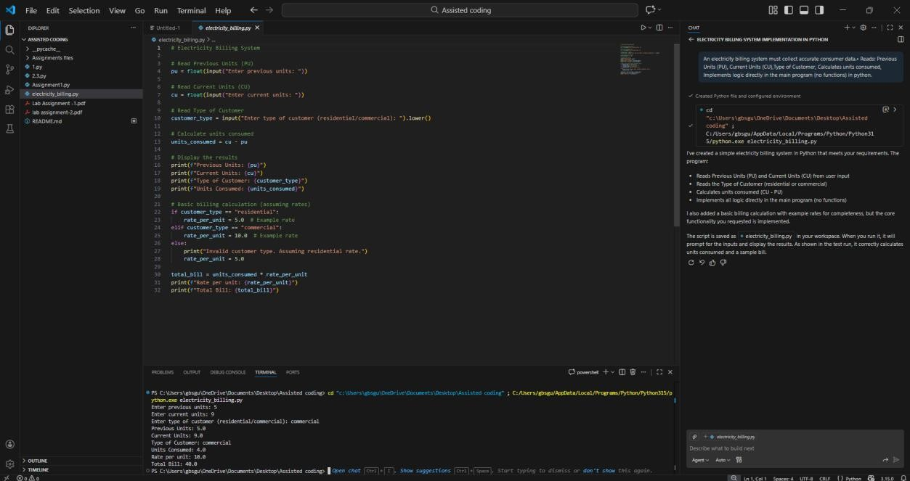
Task 2: Energy Charges Calculation Based on Units Consumed Scenario
Energy charges depend on the number of units consumed and customer type.
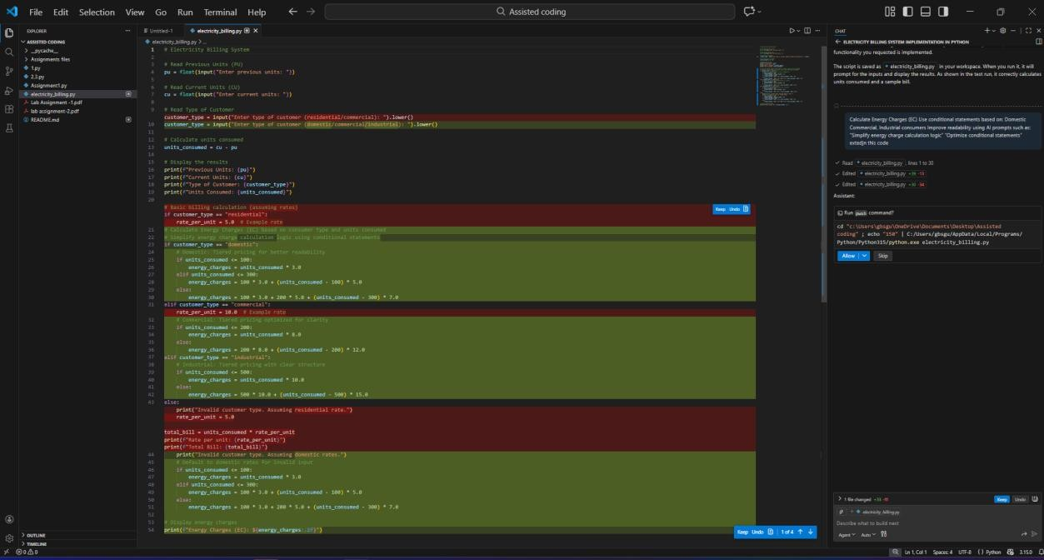

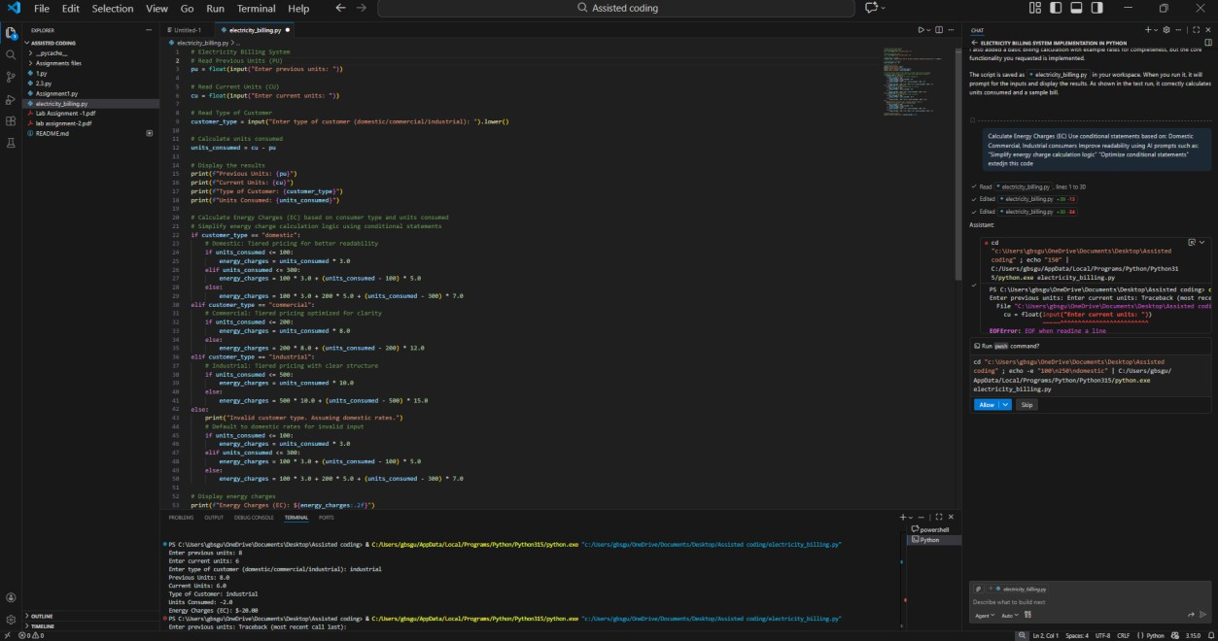
Task 3: Modular Design Using AI Assistance (Using Functions) Scenario
Billing logic must be reusable for multiple consumers.

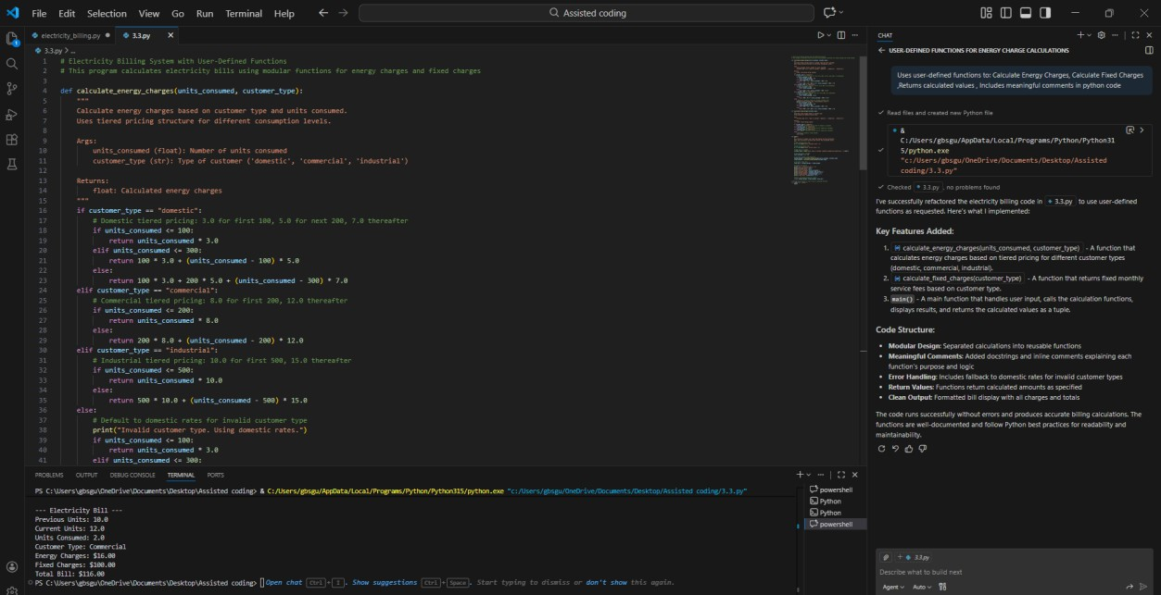

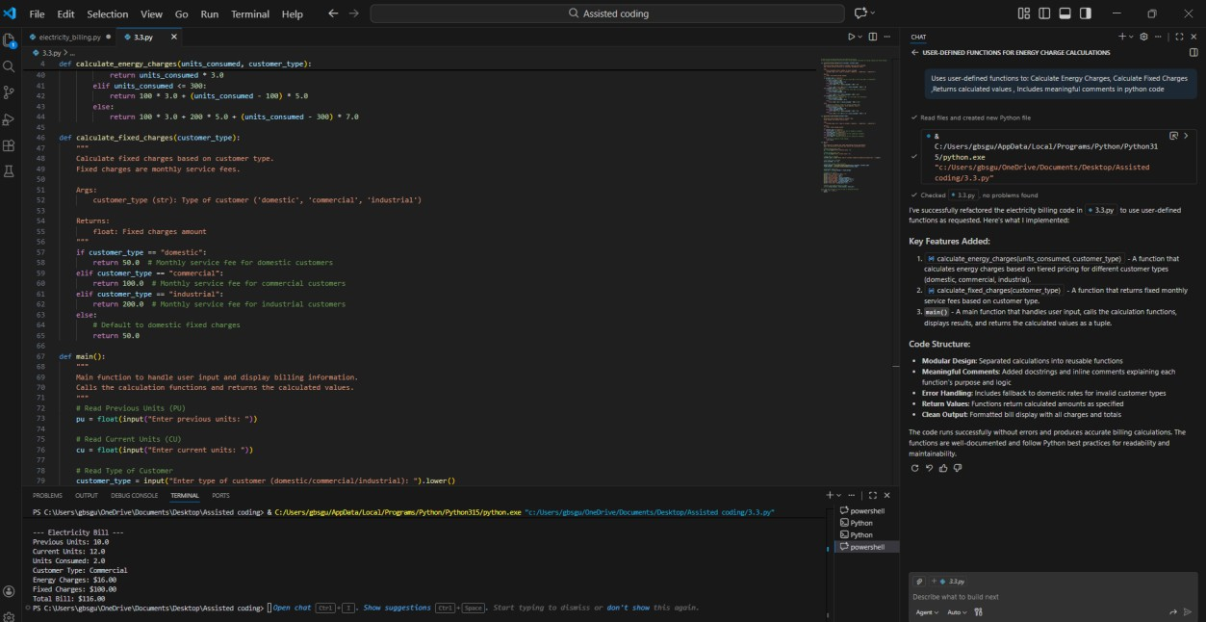
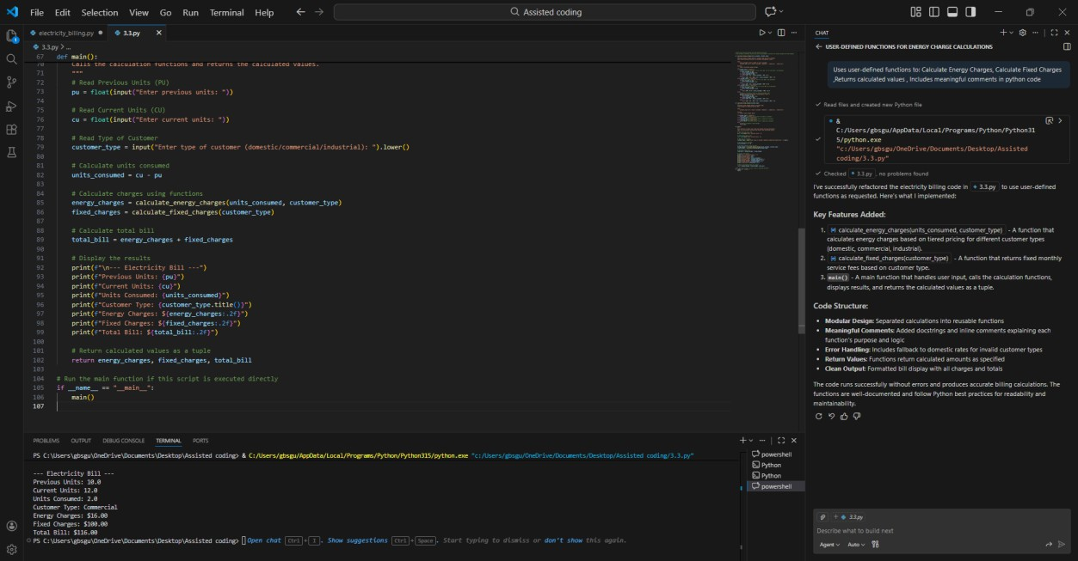
Task 4: Calculation of Additional Charges Scenario
Electricity bills include multiple additional charges.

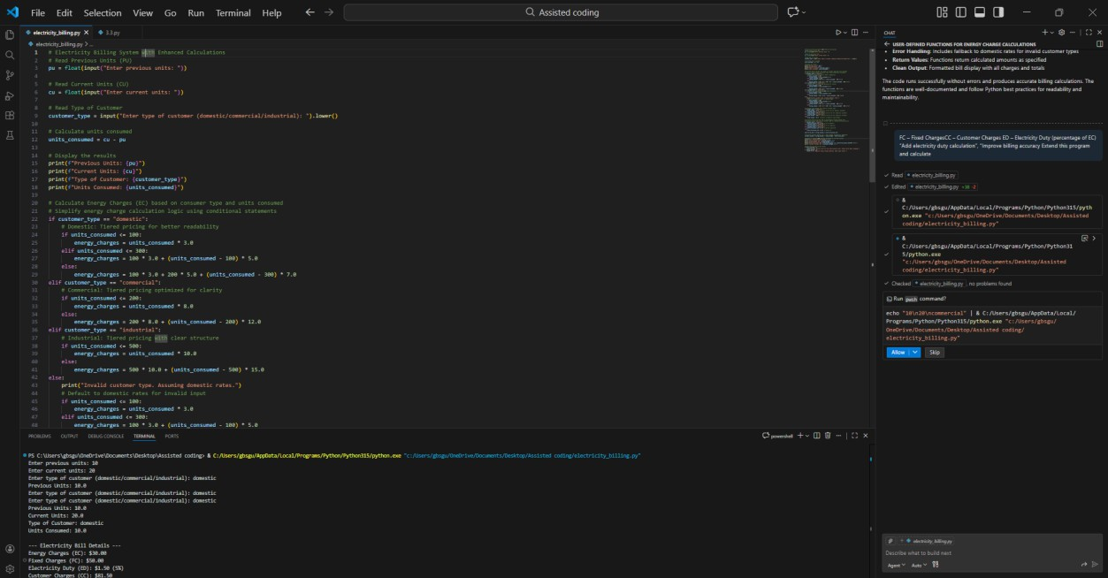
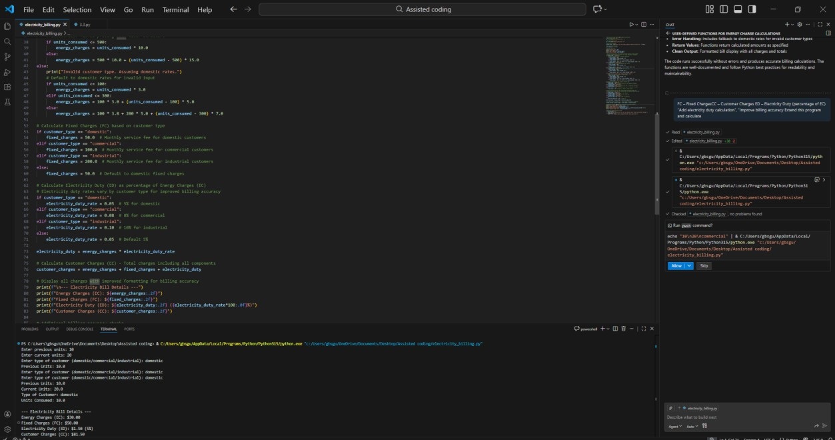

Task 5: Final Bill Generation and Output Analysis Scenario
The final electricity bill must present all values clearly.

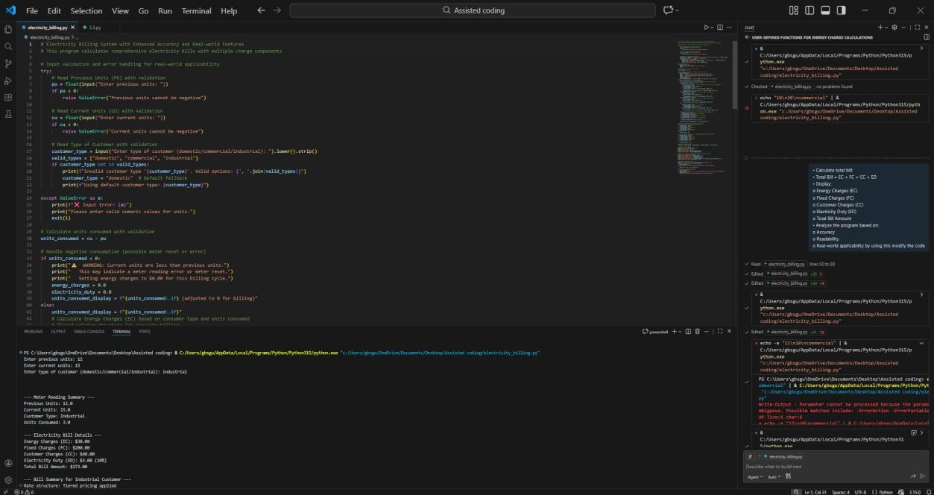
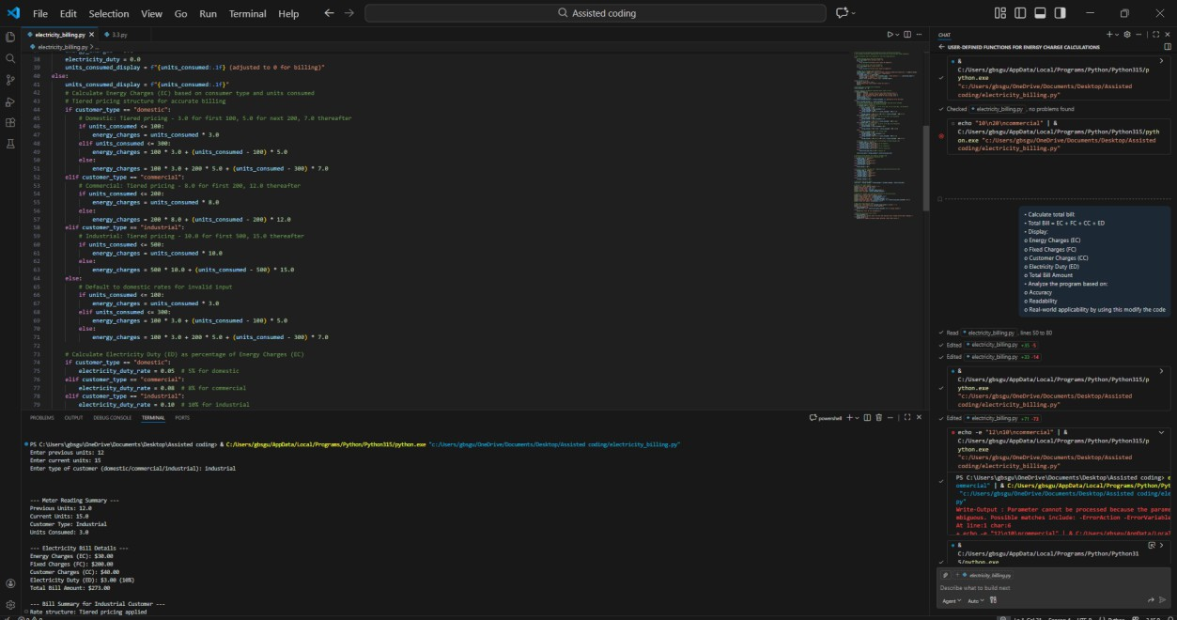

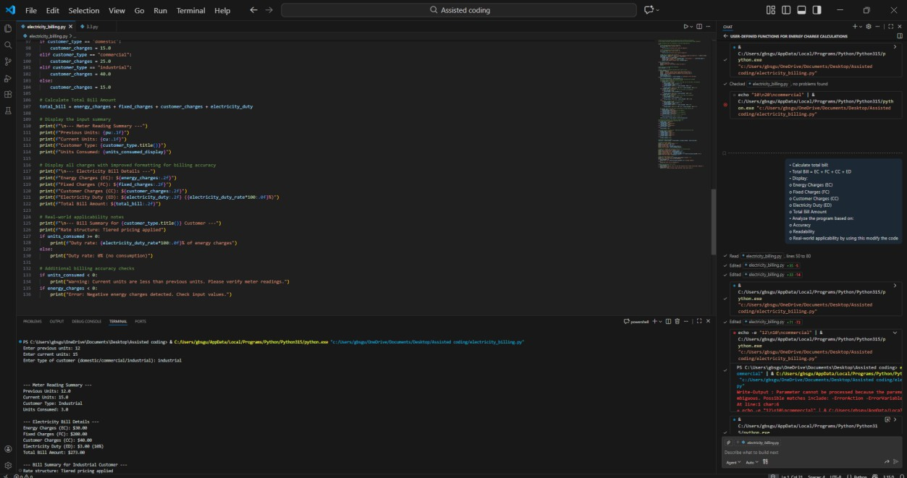
This program accurately calculates the electricity bill by using basic arithmetic formulas. The code is easy to read because of meaningful variable names and clear print statements. It is applicable in real-world situations as it follows the standard electricity billing structure used by power departments. The formatted output helps users understand each charge clearly

